ProjectDevelopmentPhase

|  |  |
| --- | --- |
| **Date** | 10November2022 |
| **Team ID** | PNT2022TMID50435 |
| **ProjectName** | SmartFashionRecommenderApplication |

SENDGRIDINTEGRATIONWITHPYTHONCODE:

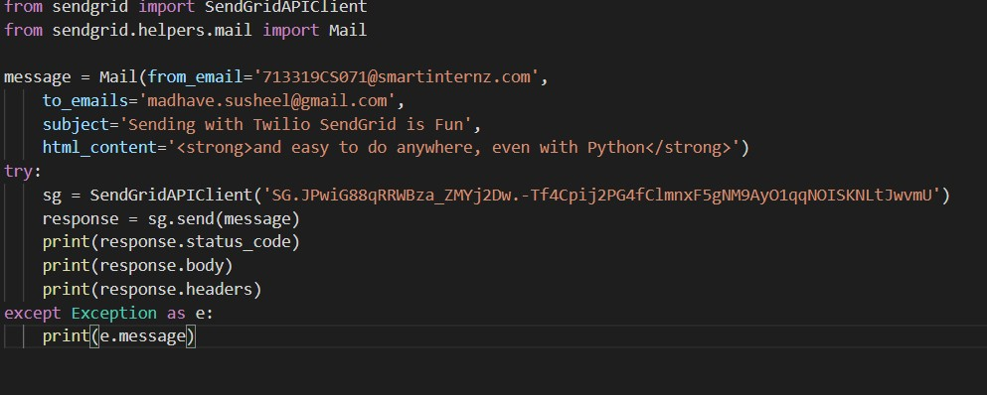

EMAILFROMSENDGRID:

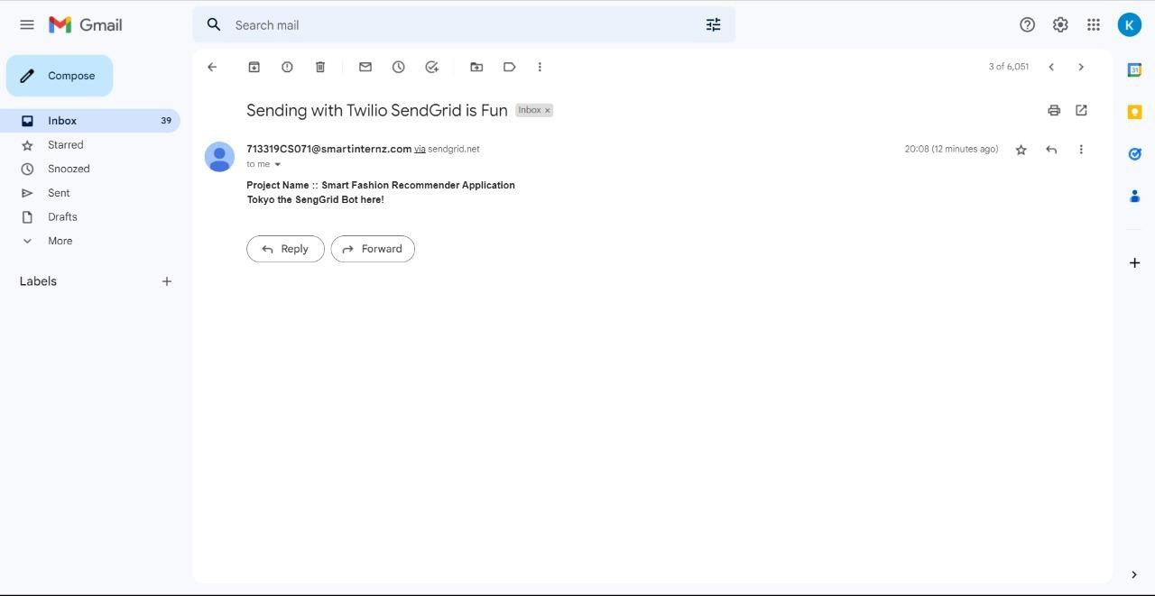

BUILDINGACHATBOT:

